Pachyderm Meeting Notes and Elaboration

Rosemary Sanchez
January 26, 2005

Document Loading
- root.swf is launched.
- root.swf looks for “presentation.xml” (hardcoded string name) and loads it.
- root.swf fills its internal arrays with the data collected from presentation.xml.
- root.swf finds the node designated as the starting screen and loads the .swf file associated with it, passing the content .xml file as a parameter (i.e. artist-in-context.swf is loaded with “26.xml” as a parameter).
- As the .swf file is loaded, root.swf pushes the xml name onto the navigation stack, so that the back button can track which screen is loaded (i.e. “26” is the bottom element on the stack when the first screen is loaded).
- Simultaneously (by means of asynchronous function calling), root.swf looks for the .xml document describing the border layout. (Currently a hardcoded string name.)
- root.swf parses the border/frame xml and renders appropriately.
- The template screen (the .swf that root loaded) is attached to root.swf.
- The template screen grabs the .xml filename parameter and parses the file, filling its internal arrays with the data collected. This usually also involves storing the asset names (with their paths) in the array.
- The objects on the template screen find the asset names from the array and load them. The template screen is now fully loaded.
- When the user interacts with the template screen to invoke the loading of a new template screen, the first template screen makes a call to root.swf.
- The first template screen is unloaded, and the new template screen is loaded just like in step 5. The stack now contains the first template screen’s xml name at the bottom and the new screen on top.
- If the user clicks on the back button, the swapping procedure as described in step 12 takes place, except the first stack element is popped off.

Asset Loading and Manipulation
Templates are responsible for loading their own assets. The asset name is parsed from the accompanying .xml file and usually stored in an array. Currently, the .xml files and the .swf files reside in the same directory, but if desired the .xml file can be stowed away in another directory with the assets directory inside it. The important thing is that the asset path name is relative to the location of the .xml file. Of course, this can be changed in the future with Actionscript manipulation.

When the template or the template’s objects load an asset, they generally assume that the asset is in .swf form so that the object can use a standard Flash “loadMovie(…)” call to load the asset. This function can also load jpegs directly, and can load variables from URLs. (More details at http://www.macromedia.com/support/flash/action_scripts/actionscript_dictionary/actionscript_dictionary423.html)

To manipulate assets (i.e. their coordinates, which components are visible, etc.), the assets must first be fully loaded. This can be accomplished with a standard “if not fully loaded, go back to loading frame, else go to the frame with manipulations” technique. The components to be manipulated must be referenced to the names given in the template (“image”, “title”, “credit_button”, etc.), but can be manipulated like any other Flash movieclip (i.e. visibility, alpha, x and y coordinates, width, height, etc.).

Hard-coded Text vs. Dynamic Text Areas
Areas of text that have hard-coded text are highlighted in blue. Text that is dynamic is in green. Red is for text from assets.

Artist in Context
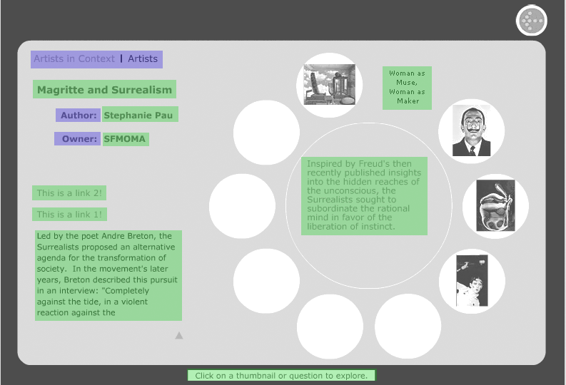

Artwork
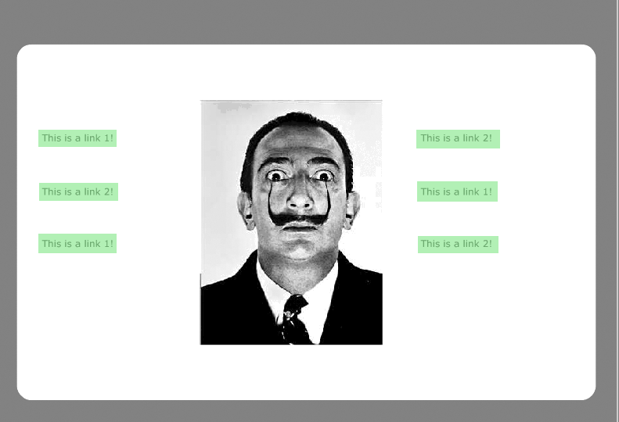

Enlargement
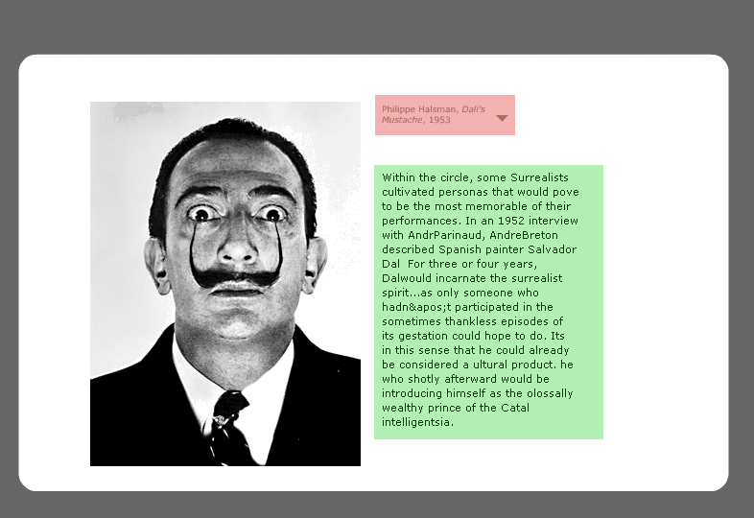

Variety of Media
